2017 SMBC Entry Form
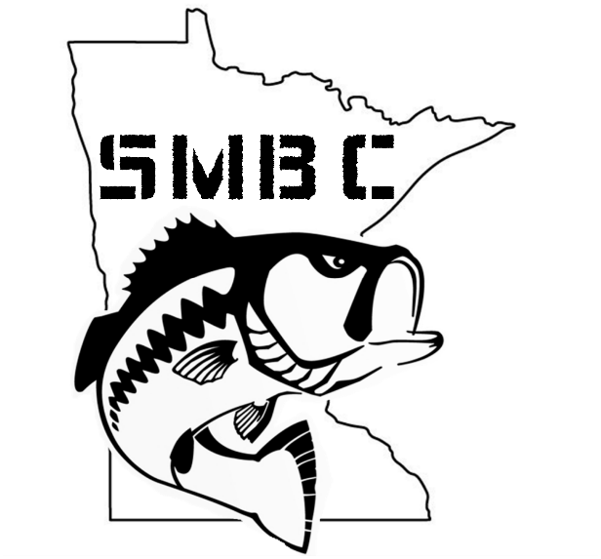

Team Name:

Captain’s Name:

Phone:

E-mail:

Partners Name:

Phone:

E-mail:

Mail entry fee $500 and form to:
South Metro Bass Club
19800 Olde Sturbridge Rd
Corcoran, MN 55340

