2020 SMBC Entry Form
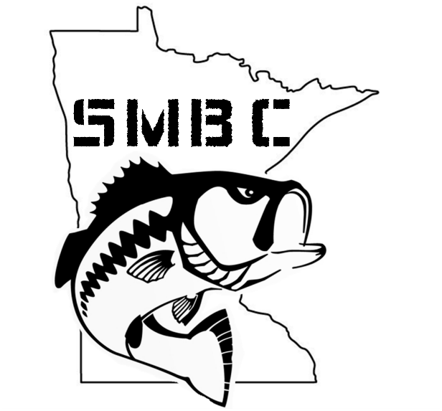

Team Name:

Captain’s Name:

Phone:

E-mail:

Partners Name:

Phone:

E-mail:

Mail entry fee $500 and form to:
South Metro Bass Club
11011 Quebec Ave N
Champlin, MN 55316

