2023 SMBC Entry Form
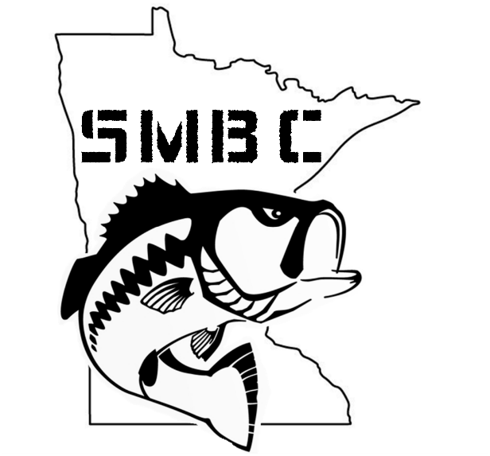

Team Name:

Captain’s Name:

Phone:

E-mail:

Partners Name:

Phone:

E-mail:

Mail or Venmo entry fee $550 and form to:
Venmo @Matt-Voigt-4
Matt Voigt
South Metro Bass Club
11011 Quebec Ave N
Champlin, MN 55316

