2018 SMBC Lake Sarah Open Entry Form
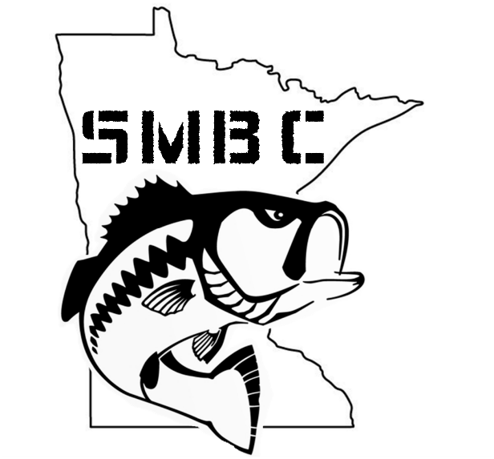

Captain’s Name:

Phone:

E-mail:

Partners Name:

Phone:

E-mail:

Mail entry fee $200 and form to:
Matt Voigt
19800 Olde Sturbridge Rd
Corcoran, MN 55340

